Chapter 4, Solution 53.

Find the Norton equivalent at terminals a-b of the circuit in Fig. 4.119.

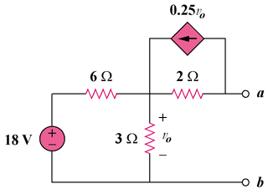

Figure 4.119
For Prob. 4.53.

Solution

To get R_{Th}, consider the circuit in Fig. (a).

(a)

3 Ω

+

v_{o}

−

1A

2 Ω

6 Ω

0.25v_{o}

b

a

0.25v_{o}

(b)

2 Ω

+

v_{o}

−

1A

2 Ω

b

a

+

v_{ab}

−

1/2

1/2

From Fig. (b),
v_{o} = 2x1 = 2V, -v_{ab} + 2x(1/2) +v_{o} = 0

v_{ab} = 3V

R_{N} = v_{ab}/1 = 3 ohms

To get I_{N}, consider the circuit in Fig. (c).

18V

+
−

(c)

3 Ω

+

v_{o}

−

I_{sc} = I_{N}

2 Ω

0.25v_{o}

b

a

6 Ω

[(18 – v_{o})/6] + 0.25v_{o} = (v_{o}/2) + (v_{o}/3) or v_{o} = 4V

But, (v_{o}/2) = 0.25v_{o} + I_{N}, which leads to I_{N} = 1 A

